Olist Dataset Analysis:
Objective:
To analyze customer behaviour, seller performance, product category trends, and customer satisfaction in an e-commerce platform in order to identify high-value customers, top-performing sellers, fast-growing product categories, and improvement opportunities for retention and quality.
In Database we have 9 tables including customers info, geolocation, order items, orders payments etc with multiple columns.

Key Insights:
- A small segment of customers contributes disproportionately to total revenue
- Repeat customers are concentrated in specific cities, indicating location based loyalty
- Some high revenue product categories suffer from low customer ratings, posing retention risks.

Business Recommendation:
- Introduce VIP or loyalty programs for high-value customers.
- Focus retention campaigns on cities with high repeat purchase rates.
- Partner closely with top-performing sellers and incentivize product diversification.
- Investigate high-revenue but low-rated product categories to improve quality and logistics.
Assumptions:
- Only delivered orders were considered for revenue calculations.
- Freight cost is included as part of total revenue.
- Customer loyalty is measured using repeat purchases and RFM metrics.

- Business Problem:
Which types of customers generate the highest revenue and are most loyal?

select * from olist_customers_dataset;
select * from olist_order_items_dataset;
select * from olist_order_payments_dataset;
select * from olist_orders_dataset;
Subquery:
What is average revenue per customer?
With CTE1 as(
select cs.customer_id, cs.customer_city, cs. customer_state, ord.order_id, ord.order_status, ot.price, ot.freight_value
from olist_customers_dataset as cs join olist_orders_dataset as ord on cs.customer_id= ord.customer_id
join olist_order_items_dataset as ot on ord.order_id=ot.order_id),
CTE2 as
(select customer_id,order_status, sum(price+freight_value) as total_rev
from CTE1 where order_status= 'delivered'
group by customer_id, order_status
)
select avg(total_rev) as avg_rev from CTE2;
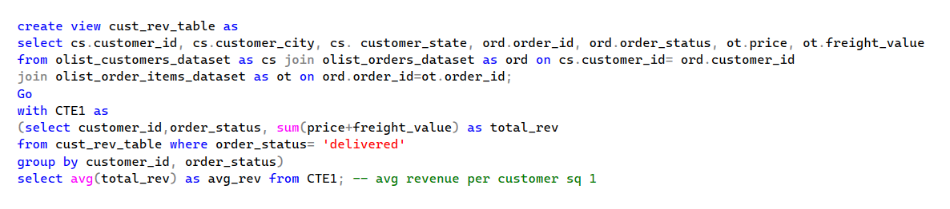

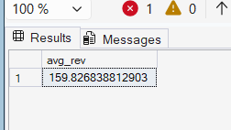
Further Analysis:
Query | Output | Analysis
With CTE1 as(  select cs.customer_id, cs.customer_city, cs. customer_state, ord.order_id, ord.order_status, ot.price, ot.freight_value  from olist_customers_dataset as cs join olist_orders_dataset as ord on cs.customer_id= ord.customer_id  join olist_order_items_dataset as ot on ord.order_id=ot.order_id)  select customer_id,order_status, sum(price+freight_value) as total_rev  from CTE1  where order_status= 'delivered'  group by customer_id, order_status  having sum (price+freight_value)>159; | 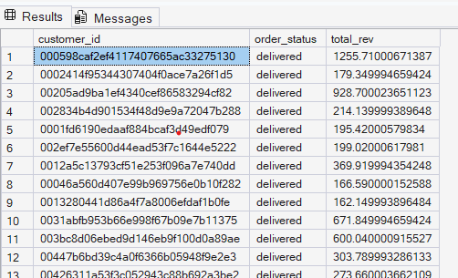 | There are 28781 customers are there who have revenue more than the average revenue per customer. We can target them for VIP programs or retention campaigns.

Who are the repeat customers vs one-time buyers as per city? Segmented by city
Here, customer id = order level id
Customer unique id= real customer identity
with CTE1 as(
select customer_unique_id,customer_city,count(distinct order_id) as ord_count from cust_rev_table
group by customer_unique_id, customer_city
having count(distinct order_id)>1)
select *, ROW_NUMBER () over (partition by customer_city order by ord_count)
from CTE1;
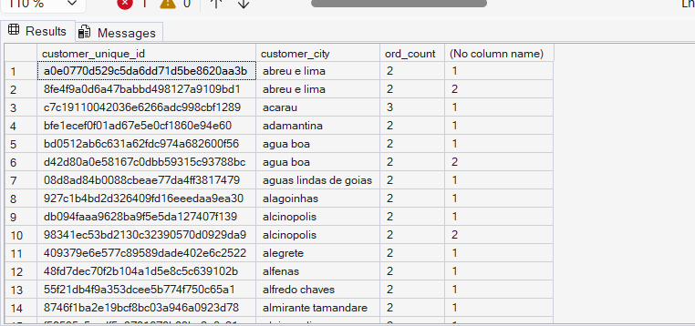

Customers with maximum orders and highest total rev segmented by city
with CTE1 as(
select customer_unique_id,customer_city,count(distinct order_id) as ord_count,
sum(price+freight_value) as total_rev from cust_rev_table
group by customer_unique_id, customer_city
having count(distinct order_id)>1),
CTE2 as(
select *, ROW_NUMBER () over (partition by customer_city order by total_rev desc) as ranked_total_rev
from CTE1)
select * from CTE2 where ranked_total_rev=1;
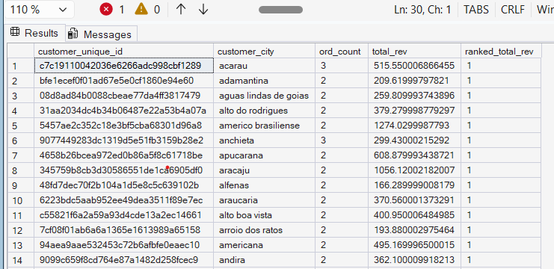

- Business Problem:
Which sellers perform best in terms of revenue, on-time delivery, and product diversity?
- Top 10 best sellers in terms of revenue
WITH CTE1 AS (
SELECT sell.seller_id,sell.seller_city,sell.seller_state,ot.price,ot.freight_value,ot.product_id,
prod.product_category_name,ord.order_id,ord.order_status
FROM olist_sellers_dataset AS sell
JOIN olist_order_items_dataset AS ot ON sell.seller_id = ot.seller_id
JOIN olist_products_dataset AS prod ON ot.product_id = prod.product_id
JOIN olist_orders_dataset AS ord ON ot.order_id = ord.order_id
WHERE ord.order_status = 'delivered'
)
SELECT
top 10 seller_id,
SUM(price + freight_value) AS total_revenue
FROM CTE1
GROUP BY seller_id
ORDER BY total_revenue DESC;
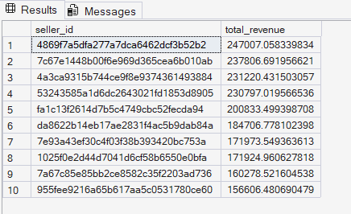

- Which sellers sell diverse product categories
We counted total distinct category names of the products and also calculates total revenue. Total count of row is total items sold.
WITH CTE1 AS (
SELECT
sell.seller_id,sell.seller_city,sell.seller_state,ot.price,ot.freight_value,ot.product_id,
prod.product_category_name,ord.order_id,ord.order_status
FROM olist_sellers_dataset AS sell
JOIN olist_order_items_dataset AS ot ON sell.seller_id = ot.seller_id
JOIN olist_products_dataset AS prod ON ot.product_id = prod.product_id
JOIN olist_orders_dataset AS ord ON ot.order_id = ord.order_id
WHERE ord.order_status = 'delivered'
)
SELECT
seller_id,
COUNT(DISTINCT product_category_name) AS num_categories,
COUNT(*) AS total_items_sold,
SUM(price + freight_value) AS total_revenue
FROM CTE1
GROUP BY seller_id
HAVING COUNT(DISTINCT product_category_name) >= 2
ORDER BY num_categories DESC, total_revenue DESC;
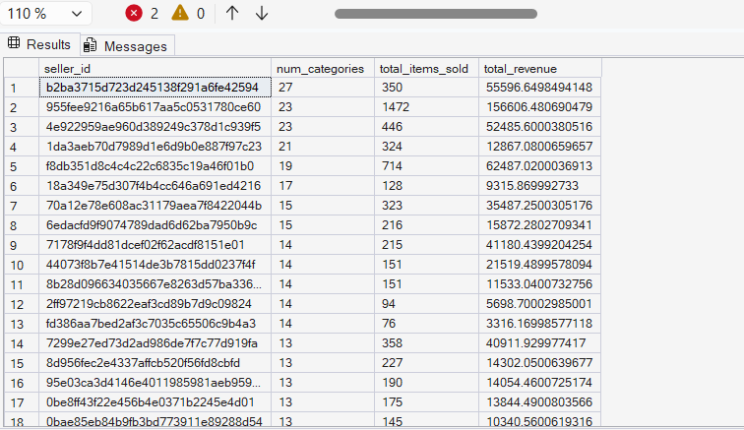

- Category wise and month wise revenue changes to identify fast growing and slow selling categories
WITH monthly_category_sales AS (
SELECT
month(ord.order_purchase_timestamp) AS order_month,
prod.product_category_name,
SUM(oi.price + oi.freight_value) AS revenue
FROM olist_orders_dataset ord
JOIN olist_order_items_dataset oi
ON ord.order_id = oi.order_id
JOIN olist_products_dataset prod
ON oi.product_id = prod.product_id
WHERE ord.order_status = 'delivered' and prod.product_category_name is not null
GROUP BY
month(ord.order_purchase_timestamp),
prod.product_category_name
),
growth_calc as(
select product_category_name, order_month, revenue,
lag(revenue) over(partition by product_category_name order by order_month)
as prev_revenue
from monthly_category_sales)
select product_category_name, order_month,revenue as current_revenue,prev_revenue,
(revenue-prev_revenue)*100/nullif (prev_revenue,0)
as pct_change
from growth_calc
order by order_month;

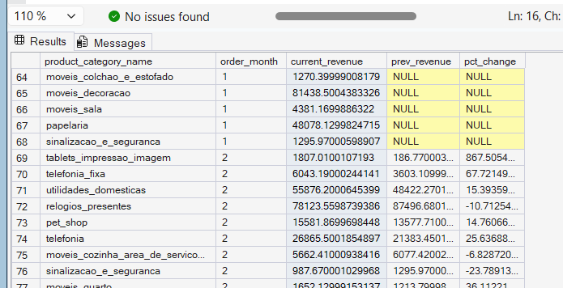

- Product categories with high revenue and low customer satisfaction

Average rating per product category
with CTE1 as(
select prod.product_id,prod.product_category_name,orv.review_score, orv.review_comment_title, ot.price, ot.freight_value
from olist_order_reviews_dataset as orv
join olist_order_items_dataset as ot
on orv.order_id=ot.order_id
join olist_products_dataset as prod
on ot.product_id=prod.product_id
)
select product_category_name, avg(review_score) as avg_review_score
from CTE1
where product_category_name is not null
group by product_category_name;

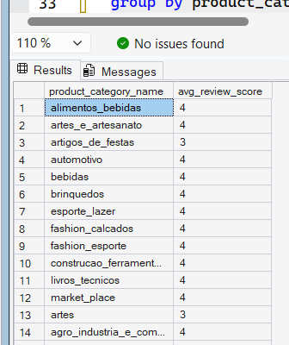
Identify top 10 products with high sales but low rating
with CTE as(
select prod.product_id,prod.product_category_name,orv.review_score, ot.price, ot.freight_value
from olist_order_reviews_dataset as orv
join olist_order_items_dataset as ot
on orv.order_id=ot.order_id
join olist_products_dataset as prod
on ot.product_id=prod.product_id
)
select top 10 product_category_name, avg(review_score) as avg_rev_score, sum (price+freight_value) as total_rev
from CTE
where product_category_name is not null
group by product_category_name
having avg(review_score)<=3
order by total_rev desc;

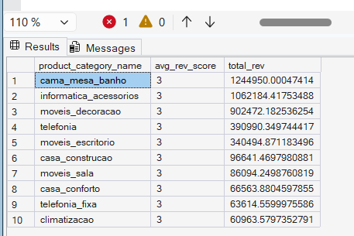

- Churn Prediction/Repeat purchase analysis
Building RFM Analysis
WITH base_orders AS (
SELECT
cust.customer_unique_id,
ord.order_id,
ord.order_purchase_timestamp,
oi.price + oi.freight_value AS order_value
FROM olist_orders_dataset ord
JOIN olist_order_items_dataset oi
ON ord.order_id = oi.order_id
join olist_customers_dataset as cust
on ord.customer_id= cust.customer_id
WHERE ord.order_status = 'delivered'
)
, rfm AS (
SELECT
customer_unique_id,
-- Recency: days since last purchase
DATEDIFF(DAY,MAX(order_purchase_timestamp),(SELECT MAX(order_purchase_timestamp) FROM base_orders)) AS recency,
-- Frequency: number of orders
COUNT(DISTINCT order_id) AS frequency,
-- Monetary: total revenue
SUM(order_value) AS monetary
FROM base_orders
GROUP BY customer_unique_id
)
select * from rfm;
Recency: How many days have been from their last purchase
Frequency: Number of orders they have placed
Monetary: Total revenue for the customers

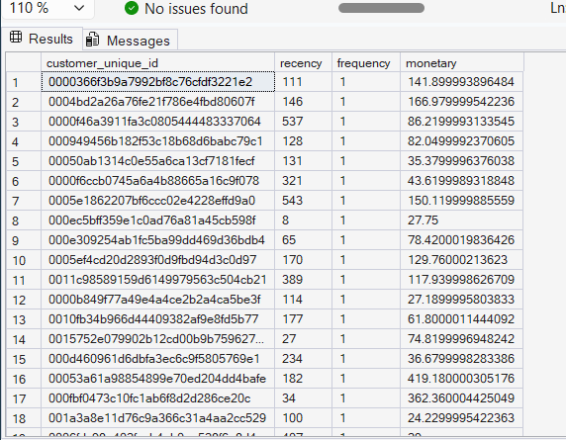

Power BI Ready Data Model
Executive KPIs:
- Total revenue- KPI Card
- Avg revenue per customer- KPI Card
- Repeat Customer rate- KPI Card
Customer Analysis:
- High vs Low value customers- Bar chart
- Repeat customers by city- Stacked Bar
Seller Performance:
- Top sellers by revenue- Horizontal Bar
- Seller Category Diversity- Scatter Plot
Product Insights:
- Category wise Monthly revenue- Line Chart
- High Revenue Low Rating Categories- Table

